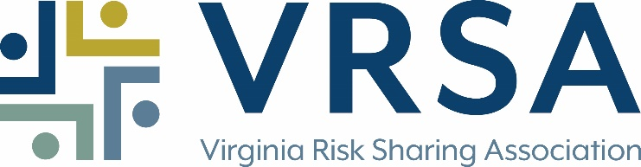

**P&L Fast Track Claims Representative**

**Virginia Risk Sharing Association (VRSA)** is the first and most financially sound group self-insurance pool in the Commonwealth insuring local political subdivisions. Since 1980, VRSA has protected our members’ assets and promoted risk management affecting strategic objectives. Beyond coverage, we provide robust education, training, tools, and resources to help members identify and treat current and emerging risks. In total, our members contribute over $60 million in annual contributions.

Headquartered in Glen Allen, VA, VRSA has 55 employees – many with over 20 years of service! Our staff enjoys a great work environment – we work but we have fun too, from monthly celebrations to chili cookoffs and picnics. VRSA offers a comprehensive benefits package to help meet your family’s unique needs. We value continuing education and professional development by providing a tuition program and a variety of learning opportunities. Please visit our website, [www.vrsa.us](http://www.vrsa.us), for additional company details, including a summary of our employee benefit programs.

Currently, we have an employment opportunity for a **Fast Track Claims Representative** to process all phases of assigned property, auto and liability claims from initial contact to conclusion in accordance with our claims handling standards. The primary focus is the timely investigation and resolution of first party auto physical damage, and third-party property damage claims with no injuries. The claims representative will be responsible for all aspects of automobile and heavy vehicle losses including the securing of vehicle appraisals, arranging rentals, settling total loss claims and handling titling and salvage processes. There is also opportunity for the handling of some first party property and minor third-party bodily injury claims.

**Responsibilities** include:

1. Provide outstanding service to customers, both external and internal, by promptly, courteously and accurately responding to verbal and written communications within established timeframes, and where appropriate and as workload permits, conducting on-site visits with members, attending meetings and maintaining current knowledge of trends in the Property and Liability field.
2. Utilize a diary to initiate timely contact on all claims; review coverage, and investigate and determine liability on all claims and work to resolution.
3. Establish, review, update and maintain reserves on all files in accordance with established standards.
4. Negotiate settlement of claims when appropriate and in the best interest of all parties, obtaining settlement authority as necessary and providing prompt notice to third party of claims that are denied.
5. Recognize subrogation/restitution possibilities for proper pursuit of recovery.

**ESSENTIAL EDUCATION SKILLS AND EXPERIENCE:**

Experience/Education:

Some claims experience in a related field in the insurance industry.

Knowledge/Skills/Abilities

1. Working knowledge of business practices and procedures and the operation of office equipment
2. Proficient in the use of personal computers including Microsoft software applications and use of the Internet for business purposes
3. Demonstrated abilities to gather and analyze information and reach sound conclusions; create and maintain hardcopy and electronic files including databases; communicate activities between software applications; work effectively with all levels of an organization; maintain confidentiality; meet deadlines and goals; and function both independently and as a member of a team

**NONESSENTIAL/BENEFICIAL SKILLS AND EXPERIENCE:**

1. Undergraduate degree in related field
2. Knowledge of medical terminology and jurisdiction issues
3. Achievement of industry related professional designation

Qualified candidates should submit a cover letter and resume to HR@vrsa.us. Attention: P&L

[www.vrsa.us](http://www.vmlins.org).

**VRSA is an equal opportunity employer. We value the unique abilities and talents each individual brings to our organization and recognize that we benefit in numerous ways from our differences.**

EOE – We value diversity!